**University of Barishal**

**Department of History,5th batch**

**PowerPoint Slide - 2024**

**Dear MD Irfan sir,**

**Assistant professor andChairman, Department of CSE, University of Barishal .**

**Sub : Group Slide by PowerPoint and MS word**

**Group : 2**

**Mohammad Sakib molla**

**Ajoy Kumar Mondal**

**Sarder Ashikuzzaman**

**Mostafizur**

**pankoj roy**

***The Battle of Plassey***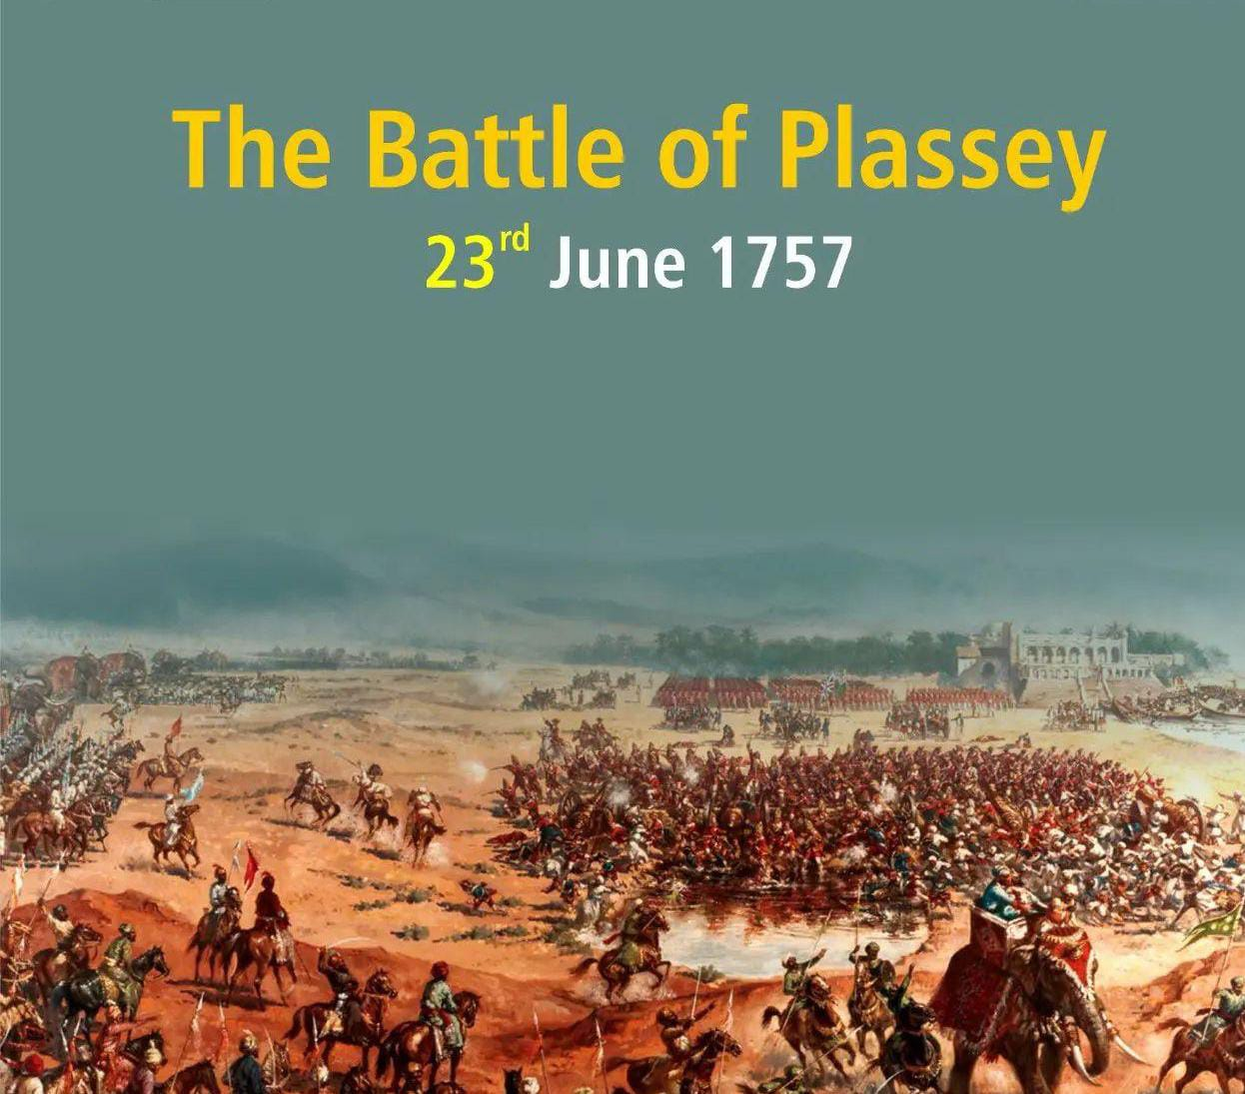

**Introduction:**

The **Battle of Plassey**, fought on **June 23, 1757**, is one of the most significant events in Indian and global history. This brief yet decisive encounter between the forces of the **British East India Company** and the **Nawab of Bengal** was a turning point that laid the foundation for British dominance in India, ultimately leading to the establishment of the **British Raj**.

**Historical Background**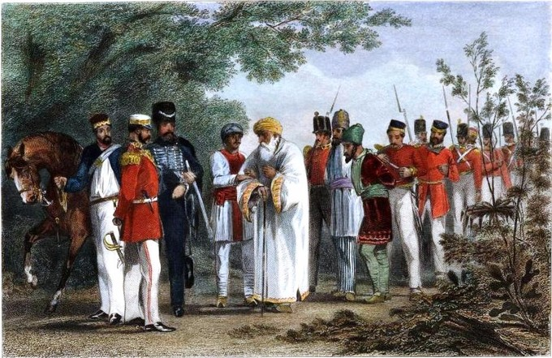

In the mid-18th century, India was a fragmented land, with several regional kingdoms and princely states vying for power. The once-mighty **Mughal Empire** was in decline, and local rulers like the Nawabs of Bengal, the Marathas, and the Sikhs sought to expand their influence. Meanwhile, European powers, including the **British**, **French**, **Dutch**, and **Portuguese**, were establishing trading posts along India's coastlines. The most significant of these was the **British East India Company**, which had trading privileges granted by the Mughal emperor.

Bengal, under the rule of **Nawab Siraj-ud-Daulah**, was one of the wealthiest provinces in India. It was a major center of trade, particularly in textiles and raw materials. However, the British East India Company, which had established its base in **Calcutta** (modern-day Kolkata), began fortifying its positions without the Nawab’s permission. Siraj-ud-Daulah saw this as a direct challenge to his authority and sovereignty, and tensions escalated rapidly.

**Causes of the Battle**

Several factors led to the conflict between Siraj-ud-Daulah and the British East India Company:

1. **Fortification of Calcutta**: The British, fearing a French invasion during the global **Seven Years' War**, began fortifying their positions in Calcutta. The Nawab, viewing this as a violation of his authority, demanded that the fortifications be dismantled, which the British refused to do.
2. **Alleged British Support for Siraj’s Enemies**: Siraj-ud-Daulah believed that the British were harboring and supporting his internal rivals, including certain disgruntled nobles and merchants.
3. **Economic Exploitation**: The British were expanding their trade and wealth in Bengal, often bypassing the Nawab's taxes and regulations. This was seen as an economic drain on the province.

These issues came to a head when Siraj-ud-Daulah attacked and captured Calcutta in June 1756. In response, the British, under **Robert Clive** and **Admiral Charles Watson**, recaptured the city early in 1757. With the situation at a stalemate, both sides prepared for a decisive battle.

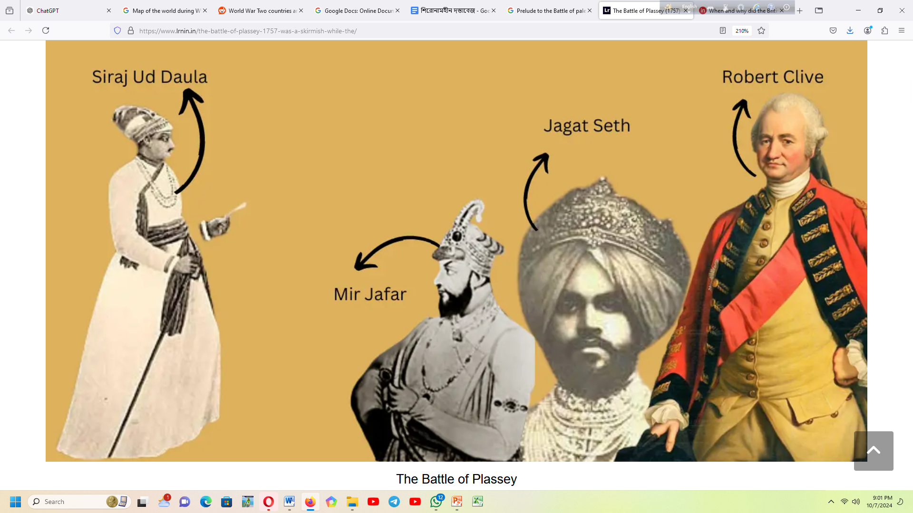

**Prelude to the Battle**

While military preparations were underway, Robert Clive employed a strategy of **diplomacy and intrigue** to weaken Siraj-ud-Daulah’s position. Clive secretly negotiated with several of Siraj’s key officials, most notably **Mir Jafar**, the Nawab’s commander-in-chief. Mir Jafar, dissatisfied with Siraj’s leadership and seeking power for himself, agreed to support the British in exchange for being

Clive's plan relied heavily on **Mir Jafar's betrayal** during the battle. With this clandestine alliance in place, the British were confident of their chances despite being vastly outnumbered.

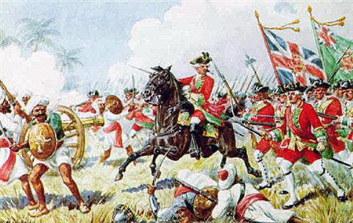

**The Battle of Plassey**

The Battle of Plassey took place near the village of **Plassey**, on the banks of the **Bhagirathi River** in Bengal. On June 23, 1757, the British forces, comprising around **3,000 troops** (including British soldiers and Indian sepoys), faced the Nawab’s army of approximately **50,000 soldiers**.

Although Siraj-ud-Daulah's forces were numerically superior, they were not well-coordinated. Additionally, a sudden **rainstorm** just before the battle rendered much of the Nawab’s gunpowder useless, as his soldiers had failed to protect their supplies. On the other hand, the British had kept their gunpowder dry, which allowed them to continue their artillery fire.

Mir Jafar, commanding a significant portion of the Nawab’s army, stayed inactive during the battle, betraying Siraj-ud-Daulah as promised. His inaction led to confusion and a collapse of morale among the Nawab’s troops. Facing growing disarray and seeing no support from his key commanders, Siraj-ud-Daulah fled the battlefield.

The battle, which lasted only a few hours, ended in a decisive British victory.

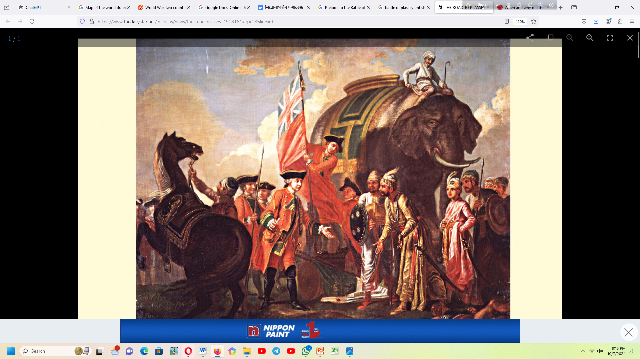

**Aftermath of the Battle**

In the immediate aftermath of the Battle of Plassey, the British East India Company installed **Mir Jafar** as the Nawab of Bengal. However, Mir Jafar was merely a puppet, and the true power in Bengal rested with the British. The East India Company quickly gained control over Bengal's immense wealth, which included its rich agricultural lands, trade, and tax revenues.

This victory at Plassey marked the beginning of the transformation of the British East India Company from a trading enterprise to a **territorial power**. Bengal, one of the richest regions in the world at that time, became the economic base for the Company’s further expansion into other parts of India. The control of Bengal's resources significantly strengthened the British presence in India and allowed them to expand their political and military influence across the subcontinent.

**Robert Clive**, hailed as a hero in Britain, was rewarded with wealth and titles for his role in the victory. However, his governance of Bengal was marred by corruption and mismanagement, which would eventually lead to economic instability and one of the worst famines in Bengal's history.

**Broader Consequences**

The Battle of Plassey had far-reaching consequences:

1. **Colonial Expansion**: The battle marked the beginning of British colonial dominance in India. Over the next century, the British East India Company, using a combination of military might and political manipulation, would extend its control over much of the Indian subcontinent.
2. **Economic Drain**: The British systematically drained Bengal’s wealth, leading to economic decline. The region, once prosperous, suffered under heavy taxation, forced revenue collection, and the diversion of its resources to Britain.
3. **The Famine of 1770**: The British exploitation of Bengal’s resources and their mismanagement of the region’s economy contributed to the **Bengal famine of 1770**, which resulted in the deaths of millions of people.
4. **End of French Influence**: The battle also effectively ended French ambitions in India. The **French East India Company**, which had been a rival to the British, could not match the British militarily or diplomatically after Plassey. This allowed the British to become the dominant European power in India.
5. **Beginning of the British Raj**: Though the British Raj formally began in 1858 after the **Indian Rebellion of 1857**, the groundwork for British rule in India was laid by the events following the Battle of Plassey. The victory at Plassey enabled the British to consolidate power, leading to nearly two centuries of colonial rule.

**Conclusion**

The **Battle of Plassey** is remembered as a pivotal moment in history, symbolizing the beginning of British colonial rule in India. While the battle itself was a brief military engagement, its impact was profound and lasting. It not only reshaped the political landscape of India but also altered the course of global history by setting the stage for British imperial expansion. The legacy of Plassey is one of exploitation, economic decline, and the eventual rise of Indian resistance to colonialism. Today, the battle serves as a reminder of the complex dynamics of power, politics, and imperialism.